**Create Azure Web App:**

1. Create Resource Group by navigating **All** **Services**🡪**Resource Group**

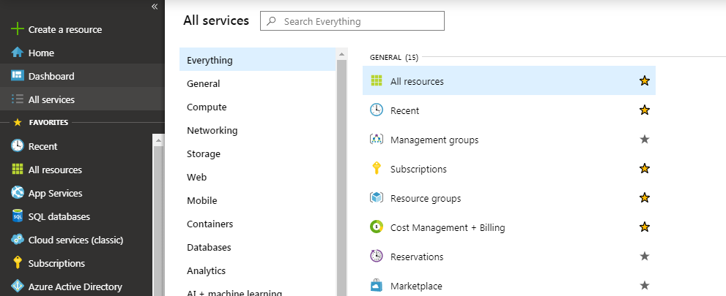

1. Click on “+Add” to create a new resource group.

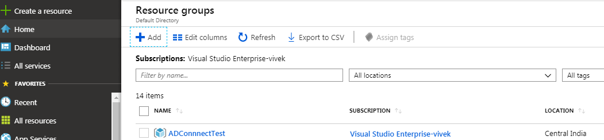

1. Enter the resource group name and select the region, select **Next**.

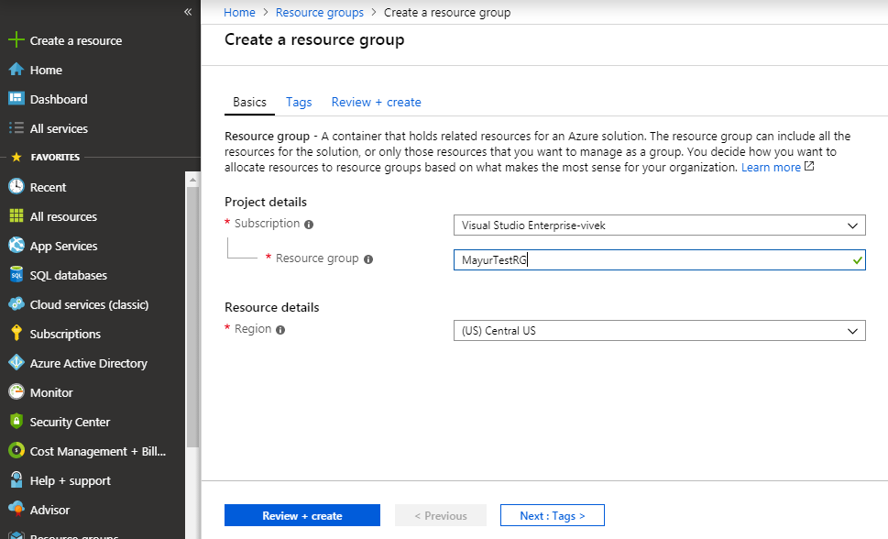

1. Validate the details and click on create.

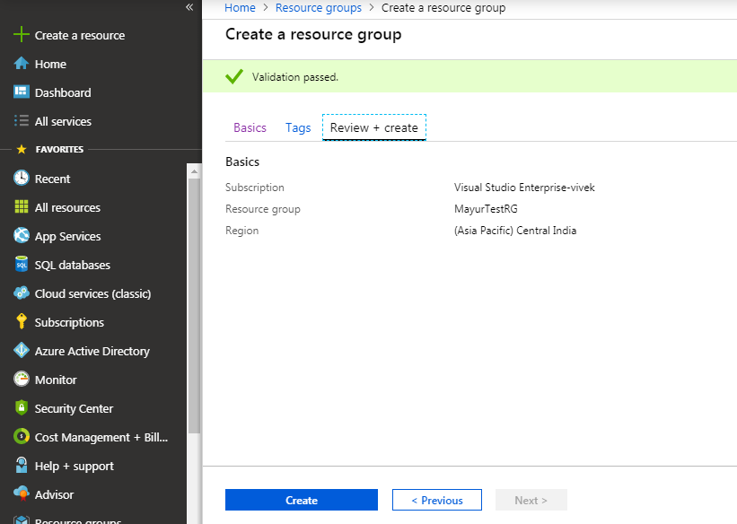

1. Check the Resource Group under Resource Group list.
2. To create the App Service navigate to All Services and search with App Services.

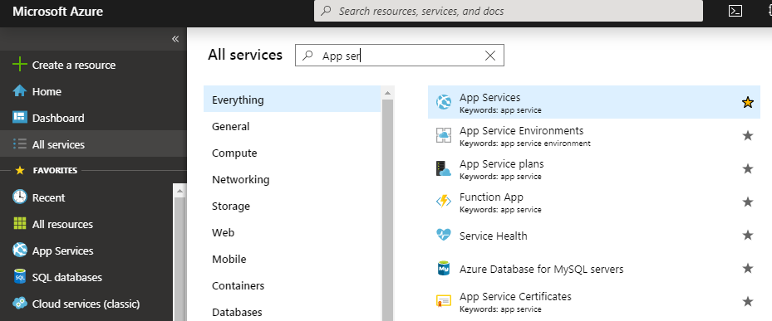

1. Click on App Service and then click on “+Add” to create a new App Service.
2. Enter all the required details, select the resource group create earlier and click on Next.

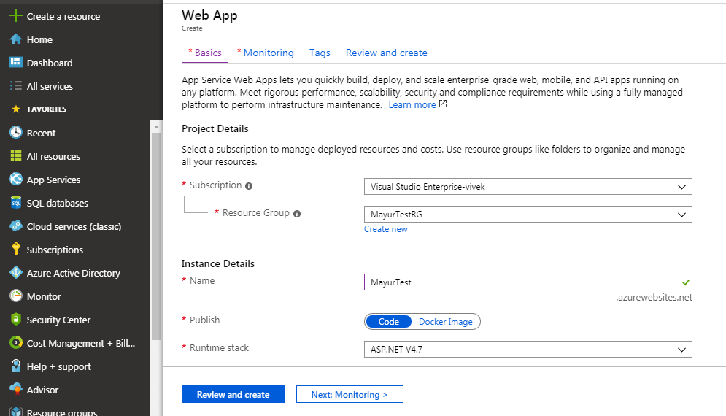

1. Review all the information on the Review and create page and click on create.

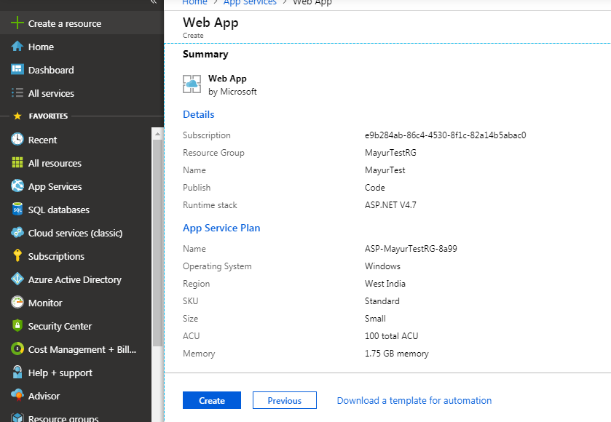

1. Click on Go to resource to check the Web App created.

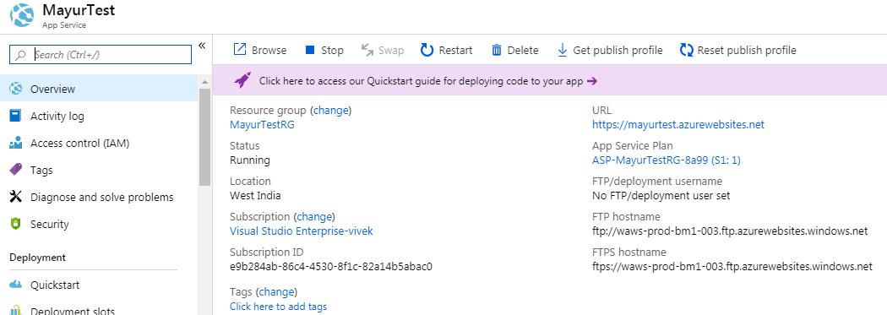

1. Copy the URL and paste in any browser to check the default web page.

